**Qingyuan Luther lifting equipment manufacturing Co., Ltd.**

Good faith and efficient innovation development is quality is spirit is sharpening

Name：Permanent Magnet Lifter

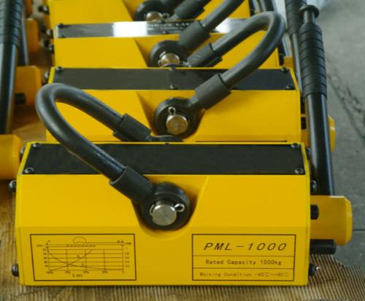

concept

The permanent magnet and permanent magnet lifter, magnetic suspension, magnetic lifter, crane lifting magnet, permanent magnet, permanent magnet etc.. It has the characteristics of small volume, stronger suction force, no electricity, almost zero remanence and high safety factor.

Main uses

Permanent magnet sucker (also known as the permanent magnet lifter, Permanent Magnet Lifter) into manual type permanent magnet lifter and automatic permanent magnet crane two, using modern high performance Nd-fe-B NdFeB magnetic material, the smaller, lighter weight, better retention, unique magnetic circuit design the residual magnetism is almost zero. High safety coefficient, the maximum pull-out force is rated 2.8-4 times of gravity. Manual type permanent magnet lifter handle with safety switch button, single hand operation, convenient and safe. The design of "V" groove on the bottom face. Full automatic permanent magnet crane without human pull handle, by lifting the electric hoist hook can control adsorption, round steel, steel plate, lifting the corresponding electricity, safe use, widely used in steel lifting, installation and handling machinery and all kinds of mold parts of the formation of. It is suitable for lifting and handling of steel plate in shipbuilding, engineering machinery and automobile industry. It is mainly used for connection with hoisting workpieces during lifting process (for example, with ring chain electric hoist, wire rope electric hoist and other matching) for mobile iron plate, block and cylindrical magnetic conducting material. The operation is convenient, safe and reliable, and the result is compact and light. It is widely used in factories, wharves, warehouses and transportation industries. Improve the working conditions of handling and handling, and improve the efficiency of labor.

Characteristic

1. The structure is small, compact and easy to operate.

2. High performance permanent magnetic materials, non demagnetization

3. No power or other power support is needed at work

4. The design of magnetic circuit balance of advanced science, strong suction force, almost zero remanence, safe and reliable

5, the maximum pull-out force is rated 3.5 times of gravity, high safety factor

Scope of application

Application and lifting cylinder block diagram

Application and lifting cylinder block diagram

Illustration of application and hoisting steel plate

Illustration of application and hoisting steel plate

Permanent magnetic chuck is suitable for handling steel, iron and steel cylinder. Such as mechanical parts, punch moulds and all kinds of steel materials. The permanent magnet lifter is a kind of power lifting equipment. The permanent magnet structure is advanced, according to export standard production, quality performance reached the international advanced level of similar products. The permanent magnet is widely used in machinery industry, mold manufacturing, warehouse and transportation departments handling magnetic materials such as steel, steel ingot.

Advantage

1. permanent magnet magnetic circuit design using computer simulation, reasonable magnetic field distribution, magnetic penetration depth.

2. permanent magnet separator body than the electromagnetic separator is simplified, without excitation power, no cooling system.

3. permanent magnet energy saving, low failure rate.

4. permanent magnet lifter has the advantages of simple operation, safe and reliable operation.

1. permanent magnet lifting jack the technical indicators are in line with the JB/T8711-1998 standard.

structure

The permanent magnet by high performance NdFeB permanent magnetic material magnetic system, by turning the handle, change the magnetic system of magnetic workpiece holding and releasing. Jack has filed for an upper ring, a V shaped groove for holding a cylindrical object with the corresponding. Permanent magnet high performance permanent magnetic materials by Jack is a rare earth permanent magnet NdFeB magnetic source, has the characteristics of no power consumption, strong suction, low remanence, convenient operation, long service life, safe and reliable, advanced structure, according to the export standard production, quality and performance reached the advanced level of similar international products. It is widely used in the machinery industry, the mold manufacturing industry, the warehouse and the transportation and other departments to carry the magnetic materials such as steel plate and ingot.

Working principle

The working principle of permanent magnet lifting jack is the use of the principle of Faraday electromagnetic induction to manufacturing. The internal use of the high performance permanent magnetic materials of neodymium borax, can produce a strong suction in the magnetic circuit, the magnetic field lines so that the jack handle turn at work or in a closed state; without external power supply, is a safe and energy saving, high efficiency of new lifting tools.

When Jack is working, Jack at the bottom of the lifting surface of the longitudinal magnetic pole, will hold firmly the iron workpiece material, and V shaped groove on the bottom surface, thus to ceiling plate shaped workpiece, also can absorb the hanging cylindrical workpiece. The jack of sheet thickness and area have strict requirements.

Usage method

1, when lifting, the surface of the workpiece is cleaned first, such as rust skin and protruding spines should be cleaned. The center line of the permanent magnet lifting jack best and workpiece center line of gravity coincide, then Jack placed on the working plane, by rotating the handle "-" to the "+" position, direction of rotation to the limit pin. Check whether the guard inclined block of the handle is automatically locked and then hoist.

2, when lifting the workpiece, it is strictly prohibited to overload. It is strictly forbidden to penetrate the human body under the workpiece. The temperature and ambient temperature of the suspended workpiece is not greater than 80 degrees, without severe vibration and impact.

3. When the cylindrical workpiece is suspended, the B - shaped groove and the workpiece angle should be kept in line with two straight lines, so its gravity is only 30%-50% of the rated gravity.

4. After the lifting is completed, the handle button is pressed inward, and the security key on the handle is separated from the security pin. The handle is rotated from the "+" to the "-" direction to the limit pin. The jack is in a closed state, receiving the workpiece and the jack out.

Maintenance and safety instructions

1, the permanent magnet in the lifting and moving the use of the process, should avoid contact with the collision knocking, so as not to affect the performance and life. The best oil is used to protect the bottom surface and clean it when used.

2. Please read the instructions before using it and use it after the use of the performance. If there are any unidentified points, please contact the manufacturer to avoid accidents.

3, we should always check the flexibility of the parts and spare parts.