**Qingyuan Luther lifting equipment manufacturing Co., Ltd.**

Good faith and efficient innovation development is quality is spirit is sharpening

Catalog

1 brief introduction

2 classification

3 characteristics

4 use

5 scope of application

6 use of attention

1.Brief introduction of lifting tongs

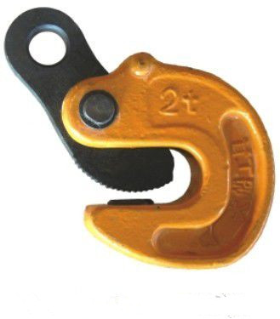

Lifting clamp and steel hanging clamp, steel lifting clamp, elevators, tongs, is a kind of lifting equipment. When lifting operation, it will pop up the horizontal hanging clamp jaw and clip it on the heavy work to be carried out. When it is disassembled, it should remove the sling when there is no load on the ground. The vertical hanging steel plate hanging pliers have self locking device, and the work is safe and reliable. The clamping speed is high and the work efficiency is high. Beautiful appearance, easy to use, no need to maintain. The rail clamp is made of high quality alloy steel. It is safe and reliable, compact and light weight. The fixed hanging beam is easy to install, and the width of clamping rail is adjusted quickly and conveniently. It is widely used in automobile, aviation, metallurgy and other fields.

Classification of 2. heavy lifting pliers

Steel plate hanging pliers, vertical hanging steel plate tongs, flip tongs, laminated steel plate tongs, single board sling pliers and so on.

3. hoisting pliers characteristics

It is made of low carbon and high quality alloy steel. It is safe and reliable, compact and light weight. The fixed hanging beam is easy to install and adjust the width of clamping rail quickly and conveniently.

Use of 4. heavy lifting tongs

It is mainly used for the horizontal and vertical lifting of the steel plate and the turnover of the steel.

The scope of application of 5. heavy lifting tongs

It is widely used in shipbuilding, steel structure installation, steel market, machining, steel plate welding, steel plate cutting, steel plate horizontal transportation and steel vertical moving.

Precautions for the use of 6. heavy lifting tongs

(1) suspended loading and hanging operation must be carried out by the qualified person who hangs and hangs the operation.

(2) select the machine suitable for use.

(3) use in the range of allowable load.

(4) the allowable plate is used in a thick range.

(5) no heavy lifting, a stage suspension, a total suspension, a leaning crane and a horizontal hoist.

(6) never enter the falling or overturning area of the crane.

(7) not to strike or collide with the hanger and hanger.

(8) no drastic movement or sharp stop is allowed.

(9) to avoid hanging on, in order to secure the best use of more than 2 hanging scissors.

(10) check before use, bite head, gasket, intertooth clogging, wear state and other abnormal phenomena, and then use it after inspection.

(11) the use of overload is strictly prohibited.

(12) strictly in weight bearing, long stay in the half empty.