**Qingyuan Luther lifting equipment manufacturing Co., Ltd.**

Good faith and efficient innovation development is quality is spirit is sharpening

Definition: lifting machinery for lifting heavy objects vertically through a sprocket

Classification: single, double and multi pulley pulley block

Features: light weight, compact structure, easy to use

IMG_256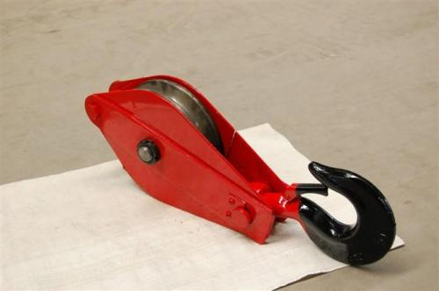

brief introduction

The heavy hoist (hoisting block) is commonly known as hoisting hoist is an important hoisting tool, the lifting trochlear structure is simple, easy to use. A simple lifting machine for lifting heavy objects vertically through a sprocket or a reel. It is light in self weight, compact in structure and convenient in use, and is suitable for simple lifting work in construction.

According to the number of wheel lifting pulley can be divided into single, double and multi pulley pulley block. According to the connecting way of the trolley and the hoist, it can be divided into four kinds of hook type pulley, chain ring type pulley, ring type pulley and hanger type pulley.

According to the different bearing tonnage, the hoisting pulley can be divided into hoisting hoisting trochlear, hanger type hoisting trochlear, chain ring type lifting trochlear, and hanger type lifting pulley. The specific models include: YB double ship lifting rings, steel cable lifting pulley blocks, YB single ship lifting rings, steel cables, lifting blocks, three wheel chain hoisting blocks, three wheel hooks, lifting blocks and so on. The hoisting trochlear is divided into the national standard and the non - standard lifting heavy trochlear.

A lifting tackle can only change the direction of the force, and it can't save labour. The pulley group composed of two blocks can achieve the goal of saving labour on the basis of changing the direction of departure. In the lifting operation, a single block can be used as a guide pulley; pulley block with hoist for lifting purposes.

The ball bearing and roller bearing wheel core of the lifting block is the national standard bearing, and each pulley is two. According to the lifting tonnage, the bearings with different specifications and standards can be applied to high speed and no maintenance.

Classification and structure

The hoisting trolley is also called the iron pulley and the pulley. It is used in lifting operations and rigging, hoisting and hoisting machines. It is one of the indispensable lifting tools to transport and hoist all kinds of structural equipment and components.

The pulley is divided into a fixed pulley, a moving pulley, a guide wheel and a pulley group.

(1) a pulley. A pulley is used to support the motion of a flexible piece. When the rope is subjected to force, the rotor rotates and the position of the shaft is constant. In use, it can only change the direction of the wire rope, without saving energy.

(2) a pulley. The movable pulley is mounted on a moving shaft, which is raised or reduced with the tractive work. It is hard to work with a moving pulley, but it can not change the direction of the force.

(3) guide pulley. The guide pulley is also called the door skid, which is similar to the fixed pulley. It can only change the direction of the rope, and it does not save the force.

(4) the pulley group. The pulley group is a kind of lifting tool which consists of a certain number of fixed pulleys, movable pulleys and rigging. It can not only reduce the traction force, but also change the direction of the tension. In the hoisting project, the pulley group is often used in order to lift the heavy mechanical equipment with less traction. If 0.5 ~ 20t (5 ~ 200kN) hoist is used to pull the end of the pulley block, it can finish the lifting task of several tons to hundreds of tons of heavy equipment or components.

technical requirement

(1) the trochlear should choose its tonnage and number of wheels according to the force analysis, the traction force and the volume of the rope, and should not be overloaded.

(2) the trochlear must have a certificate of qualification. It should be checked and lubricated before use, and the rotational part of the pulley must be flexible.

(3) the surface of the pulley groove of the pulley should be smooth, and there should be no defects such as cracks and scars.

(4) it is strictly forbidden to repair hoisting hooks, hoists and hanging beams by means of welding reinforcement.

(5) when a multi wheel pulley is used only part of the pulley, the lifting capacity of the trochlear should be reduced correspondingly, and the reduction value is determined according to the number of pulleys. When used, it should be used symmetrically to avoid partial loading.

(6) the minimum net distance between the two trochleers of the trochlear group is not less than 5 times that of the wheel.

(7) the two group (or more than two groups) of the trochlear group, when carrying a force, the balance device should be set in order to achieve the balance of the force.

(8) the hook of a trochlear, if there is a possible decoupling, should take measures to seal it.

(9) the guide trochlear must be chosen according to the pulling force and the guiding angle of the running rope, and the use of overloading is not allowed.

(10) the trochlear should be checked regularly, and the important parts (such as shaft, hook, ring, hanging beam) should be nondestructive. In the case of the following circumstances, the parts must be replaced.

(1) the hanging parts on the pulley found that there were cracks and plastic deformation.

The wear depth of the pulley groove is more than 20% of the diameter of the wire rope.

The part of the rim has broken damage;

(4) the wear of the wheel shaft is more than 2% of the shaft diameter.

The wear of the pulley bushing is more than 10% of the wall thickness.

The hooks, rings, hanging beam wear more than 10% dangerous section.